Introduction to DJANGO

What is Django?
Django is web application framework written in python language for developing web applications.
Django allows to develop server side programming or server side applications (OR) django in web application development used at backend.

Django Features
Features are nothing but facilities provided by django framework to web application developers.

- MVT Architecture (Model–View–Template)
- Built-in ORM (Object Relational Mapper)
- Automatic Admin Panel
- Security Features
- Authentication & Authorization System
- URL Routing System
- Template Engine
- Form Handling & Validation
- .Middleware Support
- Database Migration System
- Scalability & Performance
- REST API Support (With Django REST Framework)
- Internationalization (i18n)
- Testing Support

MVT Architecture (Model–View–Template)
An architecture define set of rules and regulations for organization of code or components or programs.
Django follows MVT architecture for developing web application
M- Model
V – View
T – Template

Model 🡪 Database Logic
View 🡪 View is a python program which acts as controller. Controller job is controlling the execution of web application. View receives input from client, process it by communication with database using model and generate output using template.

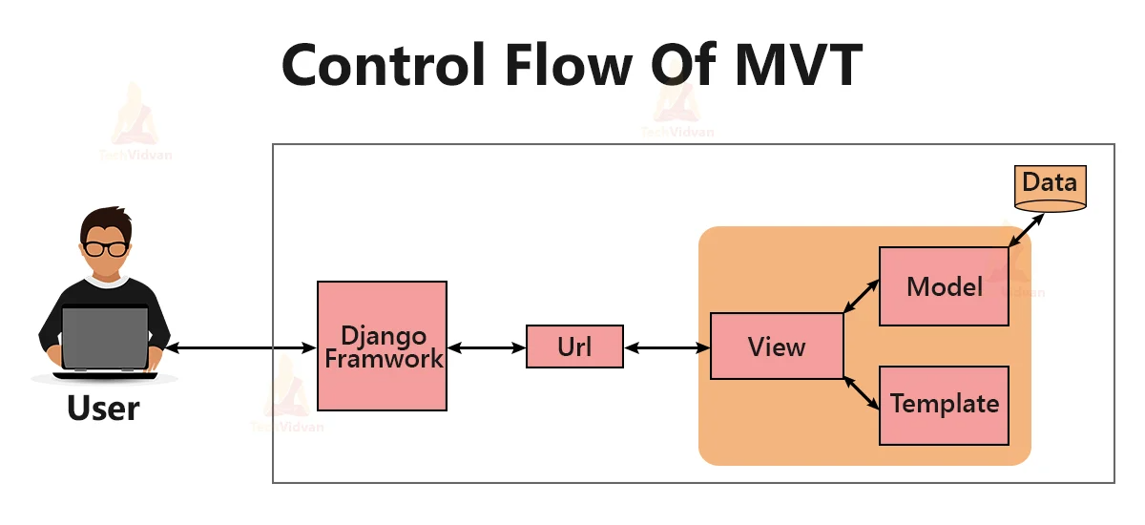

T – Template 🡪 template is an HTML file, which is used for input and output.

MVT (Model-View-Template) is the software architectural pattern used by the Django web framework to separate data management, business logic, and user interface. It consists of Models (data layer), Views (business logic), and Templates (presentation layer), with Django handling control flow, reducing the need for an explicit controller.

Advantage of MVT is,
- It is a common architecture used by all web frameworks
- It is developed based divide and conquer rule
- Easy to organize and maintain code

Built-in ORM (Object Relational Mapper)
ORM allows communicating with database using Object Oriented Programming. This allows developing database independent applications.
Django provide in-built ORM tool

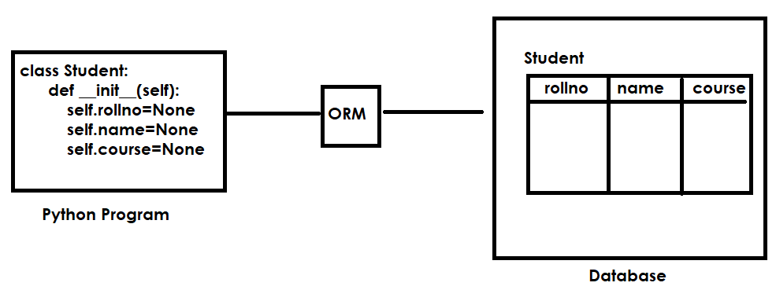

Automatic Admin Panel (Dashboard/application)

Django framework provide a predefined admin application.
This application is used for managing models (database),
Users, groups and permissions.

Security Features
Django allows to develop secured web applications.
It avoids the following problems while developing web application.

- SQL Injection:
SQL injection is a code injection technique where attackers insert malicious SQL statements into input fields to manipulate backend databases. This allows unauthorized access, modification, or deletion of data.
Django avoid SQL-injection problem using ORM (Object Relational Mapping). Django does not uses RAW-SQL statements, it communicate with database using object oriented programming.

- CSRF :
CSRF Cross site Request Forgery

A CSRF (Cross-Site Request Forgery) token is a unique, secret, and unpredictable value generated by a server-side application to protect against CSRF attacks. It ensures that sensitive requests (like form submissions) are authorized, preventing malicious sites from forcing authenticated users to perform actions without their consent.

Authentication and Authorization System
Authentication is a process of verifying user details (login)
Authorization is a process of verifying permissions/roles

Django framework provided a predefined/in-built authentication and authorization system/application.

URL routing System

URL stands for Uniform Resource Locator

URL 🡪 Uniform Resource Locator
URN 🡪 Uniform Resource Name
URI 🡪 Uniform Resource Identifier

URL 🡪 URL consist of
- Protocol
- IP-Address
- Portno
- Application path
- Resource

Django provided in-built url routing system.
Web application consists of 2 types of resources
- Private resources (Python programs)
- Public resources (HTML)
In order to call or invoke private resources or server programs by client or browser we required public name, this public name is called url or url pattern.

